Geostationary Orbit

### It orbits directly over the equator orbiting from West to East.

### It orbits at an altitude of 35,800 km (22,300 miles

TIROS

### April 1 1960

### First weather satellite

### 78 Days

### Cloud cover weather formations

### Designed by Radio Corporations of America

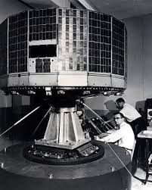

### TIROS in vibration testing at Astro-Electronic Products division of RCA.